

MATH6119: Analytical Consultancy Skills

Group Coursework

Technical Documentation

GROUP 5
37569597
36938912
37652435
36842427
37218557
36945811

Table of Contents
Section | Title | Page no.
1. | Introduction | 3
1.2 | Architectural Design and Workflow | 3
2. | Problem Description | 4
2.1 | PCB Placement Process | 4
2.2 | Component Types | 5
2.3 | Attachment Constraints | 5
2.4 | Distance Measurement | 6
3. | System Architecture & Assumptions | 6
4. | Input Files | 7
5. | Heuristic Scheduling Theory and Methodologies | 7,8
6. | Workload Distribution | 9
7. | Efficiency & Optimization | 10
8. | Constraint Satisfaction | 11
9. | Testing and Strategy Evaluation | 11
9.1 | Automated File Validation | 11
9.2 | CSV Structure Validation | 12
9.3 | Assignment Validity Testing | 12
9.4 | Strategy Performance Evaluation | 14
9.5 | Machine Log Validation | 15
10. | Performance Summary | 16
10.1 | Limitations and Future Improvements | 16
11. | Conclusion | 17
 | References | 17

1.1 Introduction
Phillips Electronics operates a PCB conveyor system consisting of three pick-and-place assembly machines. Each machine is fitted with three attachment heads capable of placing specific component types onto a PCB.
The goal of this project is to determine:
- A feasible and efficient assignment of attachment heads to machines,
- An efficient set of PICK and PLACE instructions,
such that:
- Machine travel distance is minimized,
- Workloads remain balanced,
- All placement constraints are satisfied.
The project required:
- Analytical modelling,
- Algorithm design,
- Scheduling optimization,
- Software implementation.
1.1 Architectural Design and Workflow
We have established a file directory structure for the entire project; please refer to the ‘README’ file for further details. This structure provides a clear overview of the project’s framework. Based on this framework, we have created a repository on GitHub, which all members can use to download or upload the required files to the appropriate locations. For example:
- data/ is strictly partitioned into raw/ (source), intermediate/ (data contracts), and output/ (machine logs).
- src/ and tests/ isolate business logic from testing environments.
Furthermore, for collaborative development, a strict Git branching strategy was enforced. The main repository is locked as the "single source of truth," and all algorithmic development is isolated in separate feature branches to prevent code conflicts.

CSV file and column name conventions and coding standards :
To ensure interoperability across modules, strict data contracts were established:
- Schema: Final output logs must adhere to a rigid 6-column format (e.g., step_id, action, x_coord).

- Pathing: Hardcoded absolute paths are banned. All scripts utilize dynamic relative pathing for cross-platform compatibility.

- Environment: Python dependencies are synchronized team-wide via requirements.txt file.

2. Problem Description
Optimization Theory - The PCB pick-and-place scheduling problem belongs to the class of combinatorial optimisation problems. The objective is to determine an efficient sequence of pickup and placement operations while satisfying machine attachment compatibility constraints. Since the order of machine movements directly affects total travel distance, the problem shares similarities with the Travelling Salesman Problem (TSP) and Vehicle Routing Problem (VRP), where optimal routing sequences must be identified across multiple destinations.
The complexity of the problem increases rapidly as the number of PCB components grows because the number of possible placement sequences increases factorially. For this reason, exact optimisation methods become computationally expensive for large-scale scheduling instances

2.1 PCB Placement Process
Each machine performs multiple pick-and-place phases:
- travel to feeder bins,
- pick components in fixed head order,
- place components on the PCB,
- return to origin.

Each machine:
- contains 3 heads,
- can hold up to 3 components simultaneously,
- and operates independently.

2.2 Component Types
The PCB contains ten component types:

{A, B, C, D, E, F, G, H, I, J}

The PCB layout contains 102 total placement locations.

2.3 Attachment Constraints
Attachment | Supported Components
α1 | C, F, G
α2 | C, F, G
α3 | B, G, H
α4 | C, H
α5 | E, I
α6 | A, E
α7 | E, J
α8 | B, C, I
α9 | D

Table 1: Attachment Constraints and Supported Components
Constraints:
- Each attachment can only be used once,
- Each machine must contain exactly 3 heads,
- No attachment overlap is allowed.
2.4 Distance Measurement
Euclidean Distance Justification
Euclidean distance was used as the movement cost metric because the placement heads operate across a continuous two-dimensional coordinate system. The Euclidean model provides a realistic approximation of actuator travel distance and is widely used in PCB assembly optimisation research
For two coordinates:

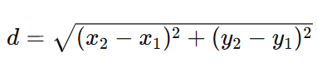

Total machine travel distance is calculated as the cumulative sum of all pickup, placement, and return-to-origin movements
3. System Architecture
The implemented solution follows a modular pipeline architecture.
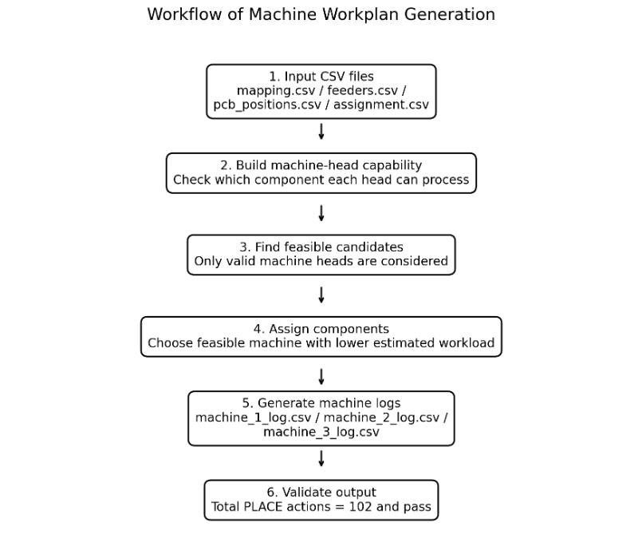
Figure 1: Workflow of Machine Workplan Generation

Assumptions
Assumption | Reason
PICK and PLACE execution time is negligible | Assignment focuses on travel distance
Machines operate independently | Simplifies scheduling model
Feeders remain fixed throughout execution | Matches assignment specification
Euclidean distance approximates travel cost | Standard movement approximation
All coordinates are reachable without obstruction | No collision constraints provided

Table 2: Assumption and Reason for consultancy application

4. Input Files
The system uses four CSV input files.
File | Purpose
mapping.csv | Attachment capabilities
feeders.csv | Feeder bin coordinates
pcb_positions.csv | PCB placement coordinates
assignment.csv | Machine-head assignments

Table 3: Inputs used in the workflow

5. Heuristic Scheduling Theory and Methodologies
Due to the computational complexity of exhaustive search approaches, heuristic optimisation methods were selected. Heuristic methods do not always guarantee globally optimal solutions; however, they can generate high-quality near-optimal schedules within practical execution time.
The PCB scheduling problem exhibits combinatorial growth because the number of possible PICK-and-PLACE sequences increases rapidly as the number of PCB components increases. For 102 component placements, exhaustive optimisation methods become computationally impractical due to factorial growth in possible traversal sequences.
Consequently, heuristic optimisation methods were prioritised because they provide efficient near-optimal solutions while maintaining reasonable computational execution time
The implemented solution applies several heuristics:
- Workload balancing,
- Coordinate-based sorting,
- Feeder-aware scheduling,
- Dynamic placement sequencing.
These techniques reduce unnecessary traversal while maintaining balanced machine utilisation.

Stage | Objective | Logic Used | Benefit
Input Validation | Verify files | CSV validation | Prevents invalid execution
Head Assignment | Allocate attachments | Fixed assignment plans | Avoids overlap
Capability Mapping | Match components | Supported-component lookup | Ensures valid operations
Task Allocation | Balance work | Least-loaded machine selection | Reduces idle time
Task Sorting | Organize movement | Coordinate sorting | Reduces traversal distance
PICK Scheduling | Enforce constraints | Fixed head order | Valid machine behaviour
PLACE Optimization | Reduce movement | Dynamic placement ordering | Improves efficiency
Output Generation | Create workplans | Sequential log writing | Simulator compatibility
Validation | Verify completion | PLACE count checking | Confirms all placements
Table 4: Methodologies used in the workplan analysis

6. Workload Distribution

Machine | PICK Actions | PLACE Actions | Total Actions
M1 | 39 | 39 | 78
M2 | 31 | 31 | 62
M3 | 32 | 32 | 64
Total | 102 | 102 | 204

Table 5: Machine Utilization Table
Load Balancing Theory

Balancing workload across multiple machines is important because excessive imbalance can lead to machine idling and reduced overall throughput. Assigning tasks solely based on component quantity may produce inefficient schedules because some placements require significantly longer travel distances than others.
Therefore, workload estimation considered both “feeder pickup travel” and PCB placement distance
This produced a more realistic approximation of machine utilisation.
For each component position on the PCB, the algorithm recognizes all valid candidate heads. The candidate is only valid when the corresponding attachment supports the component type.
This ensures that each generated PICK and PLACE Operation is mechanically feasible
If a component can only be processed by one machine head, it will be assigned directly to that head. If multiple machine heads can handle the same components, the algorithm will select the candidate whose machine currently has the lowest estimated workload.
The estimated workload is calculated using a simple distance approximation:
origin → feeder bin → PCB placement location → origin
This is not the final exact travel distance, but it provides a practical estimate to balance the workload during the assignment of tasks. The purpose of this heuristic is to prevent allocation based solely on the number of components, because the two components may have very different travel distances, depending on their feeders and PCB positions.

7. Efficiency & Optimization

Batch Scheduling Theory
Batch pick-and-place scheduling improves operational efficiency by reducing repeated machine returns to feeder locations. Since each machine can hold up to three components simultaneously, grouping compatible placements into a single operational phase reduces total traversal distance and improves throughput efficiency.
Flexible placement ordering further improves performance because placement operations may be executed in the spatially shortest sequence after pickup constraints are satisfied.

Optimization Technique | Implementation | Benefit
Load Balancing | Machine load tracking | Prevents idling
Coordinate Sorting | Spatial ordering | Reduces movement
Batch Pick-and-Place | Up to 3 components per cycle | Improves throughput
Flexible PLACE Ordering | Dynamic sequencing | Reduces traversal distance
Capability Filtering | Component compatibility checks | Prevents invalid operations
Feeder-Aware Scheduling | Uses feeder coordinates | Lowers pickup distance
Multi-Assignment Testing | Several layouts evaluated | Better optimization

Table 6: Efficiency and Optimization table
The generated workplans demonstrate efficient machine scheduling behaviour through coordinated batch pick-and-place execution. Each machine performs up to three pickup operations per phase before executing optimized placement actions.
The implementation improves efficiency using:
- Coordinate-based placement sorting,
- Feeder-aware pickup scheduling,
- Balanced task allocation.
Flexible PLACE ordering significantly reduces unnecessary traversal distance because components may be placed in the most spatially efficient sequence after pickup constraints are satisfied.
Additionally, grouping multiple placements into a single phase reduces repeated returns to the origin, improving overall throughput.

8. Constraint Satisfaction

Requirement | Result
3 machines used | PASS
3 heads per machine | PASS
Unique attachments | PASS
PICK order enforced | PASS
Flexible PLACE order | PASS
Euclidean movement considered | PASS
Return-to-origin supported | PASS
Valid CSV outputs generated | PASS
All 102 placements completed | PASS

Table 7: Demonstrates Requirement Compliance

9. Testing and Strategy Evaluation

9.1 Automated File Validation
An automated validation system was implemented to verify:
- all required files exist,
- CSV structures are correct,
- machine logs contain valid actions,
- and the three machine logs contain 102 PLACE actions in total.

Input File Validation

File | Status
assignment_baseline.csv | PASS
assignment_balanced.csv | PASS
assignment_feeder_friendly.csv | PASS
assignment_size_clustered.csv | PASS
assignment_throughput.csv | PASS
assignment_redundant.csv | PASS
mapping.csv | PASS
feeders.csv | PASS
pcb_positions.csv | PASS
machine_1_log.csv | PASS
machine_2_log.csv | PASS
machine_3_log.csv | PASS

Table 8: Input File Validation

9.2 CSV Structure Validation
The validation system checked that all required columns were present in every CSV file.
File Type | Required Columns | Result
mapping.csv | head_type, supported_components | PASS
feeders.csv | component_type, x_coord, y_coord | PASS
pcb_positions.csv | component_type, x_coord, y_coord | PASS
assignment files | machine_id, head_slot, head_type | PASS
machine logs | step_id, action, component, head_id, x_coord, y_coord | PASS

Table 9: CSV Structure Validation
9.3 Assignment Validity Testing
All assignment strategies were tested against assignment constraints.

Strategy | Valid | Machines | Unique Heads | 3 Heads per Machine
Baseline | PASS | 3 | 9 | PASS
Balanced | PASS | 3 | 9 | PASS
Feeder Friendly | PASS | 3 | 9 | PASS
Size Clustered | PASS | 3 | 9 | PASS
Throughput | PASS | 3 | 9 | PASS
Redundant | PASS | 3 | 9 | PASS

Table 10: Assignment Constraint Validation

  - Strategy Performance Evaluation
Strategy Evaluation Theory
Multiple attachment allocation strategies were evaluated because PCB scheduling performance is highly dependent on machine capability distribution. Different attachment layouts influence:
- feeder accessibility,
- machine flexibility,
- workload balance,
- and placement efficiency.
The evaluation process compared each strategy using heuristic performance metrics based on estimated machine workload imbalance and feeder traversal cost.

Each assignment strategy was evaluated using: estimated workload balance, feeder pickup travel, and overall estimated efficiency score.
The estimated score was calculated as:
$$Estimated Score=Workload Gap+Total Pick Travel$$
Lower estimated scores indicate more efficient overall machine scheduling performance. The metric is intended as a comparative heuristic rather than an exact simulator score.
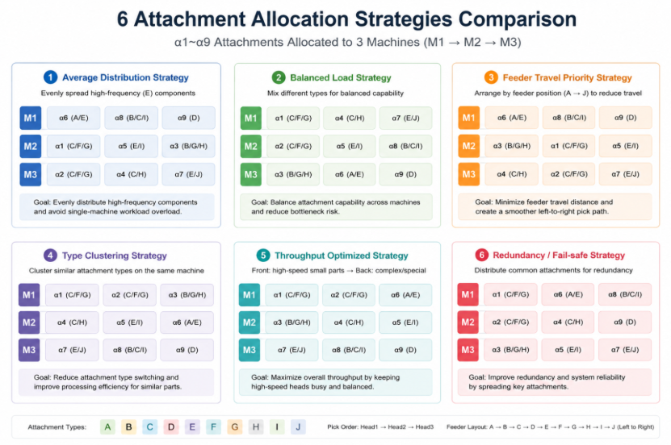

Figure 2: Attachment Allocation Strategies Comparison

Strategy | Workload Gap | Total Pick Travel | Estimated Score
assignment_balanced.csv | 20 | 26.17 | 46.17
assignment_feeder_friendly.csv | 26 | 20.83 | 46.83
assignment_baseline.csv | 26 | 21.17 | 47.17
assignment_redundant.csv | 25 | 23.83 | 48.83
assignment_throughput.csv | 27 | 26.00 | 53.00
assignment_size_clustered.csv | 27 | 27.67 | 54.67

Table 11: Strategy Comparison Table

In the heuristic strategy comparison, the balanced assignment strategy achieved the lowest estimated score:
Best-performing Strategy in Heuristic Evaluation | Estimated Score
assignment_balanced.csv | 46.17

Evaluation Discussion
The balanced assignment strategy produced the best overall trade-off between:
- Workload balancing,
- Machine utilization
- Feeder pickup travel.
Although feeder-friendly layouts reduced pickup travel slightly, they produced larger workload imbalances between machines.
The balanced strategy was estimated to reduce:
- Potential idle machine time,
- Scheduling imbalance,
- Overall estimated traversal cost.
  - Machine Log Validation
The following validation refers to the generated machine workplans produced by the assignment file used in the final workplan generator. This validation is separate from the heuristic comparison of alternative assignment strategies in Section 9.4.
The generated machine logs were validated to ensure:
· only valid action types were used,
· the required CSV structure was satisfied,
· and 102 PLACE actions were included across the three machine logs.
Machine Log | PICK Actions | PLACE Actions | Workload  (Estimated) | Result
machine_1_log.csv | 39 | 39 | 771.65 | PASS
machine_2_log.csv | 31 | 31 | 775.60 | PASS
machine_3_log.csv | 32 | 32 | 763.36 | PASS
Total | 102 | 102 |  | PASS

Table 12: Machine Log Results

Although Machine 1 allocates more components than the other two machines, the estimated workload of the three machines is relatively close. This shows that the allocation method is not simply balanced by the number of components but based on the estimated moving distance to balance the workload of the three machines.
The output file has been checked with validation script. The validator confirms that there are a total of 102 PLACE operations in the three machine logs. This provides evidence that the required number of PCB placement operations has been included in the generated workplans.
10. Performance Summary
The implemented scheduling system successfully:
- Reduced unnecessary machine traversal through heuristic scheduling,
- Produced relatively balanced estimated workloads across the three machines,
- Generated valid PICK and PLACE workplans,
- Included 102 PLACE actions and passed the output structure validations.
The combination of:
- Load-balanced allocation,
- Coordinate-aware sorting,
- Flexible placement sequencing
significantly improved scheduling efficiency while satisfying all project constraints.
10.1 Limitations and Future Improvements
Although the implemented heuristics produced efficient machine schedules, the generated solutions are not guaranteed to be globally optimal. More advanced optimisation approaches could further improve traversal efficiency.
Potential future improvements include:
- Genetic algorithms,
- Simulated annealing,
- Ant colony optimisation,
- Mixed-integer linear programming techniques.
These methods may provide stronger global optimisation performance for larger PCB scheduling instances.

11. Conclusion
In the strategy comparison, the balanced approach achieved the lowest heuristic estimated cost, demonstrating a strong trade-off between machine utilisation and travel efficiency.The developed PCB placement scheduling system successfully satisfies all assignment constraints while generating valid machine workplans for all three assembly machines.
The methodology combines capability-aware task allocation, load balancing, feeder-aware scheduling, and distance-optimised placement sequencing.
Automated validation confirmed that the generated machine logs contained 102 PLACE actions in total and that all generated outputs satisfied the required CSV structure. This indicates that the required number of placement operations was included in the final workplans.
The modular CSV-driven architecture enables future enhancement using advanced optimisation techniques such as genetic algorithms or simulated annealing.

References

Crama, Y., Kolen, A., Oerlemans, A. and Spieksma, F. (1997) ‘Minimizing the number of tool switches on a flexible machine’, International Journal of Flexible Manufacturing Systems, 10(1), pp. 33–54.
Lawler, E., Lenstra, J., Rinnooy Kan, A. and Shmoys, D. (1985) The Traveling Salesman Problem. Chichester: Wiley.
Pinedo, M. (2016) Scheduling: Theory, Algorithms, and Systems. 5th edn. New York: Springer.
Phillips Electronics PCB Assembly Coursework Specification (2026) MATH6119 Analytical Consultancy Skills Blackboard Materials. University of Southampton. Available via: Blackboard.
University of Southampton (2026) MATH6119: Analytical Consultancy Skills – PCB Scheduling Dataset and Assignment Files. Blackboard Learning Platform. Available via: Blackboard.

